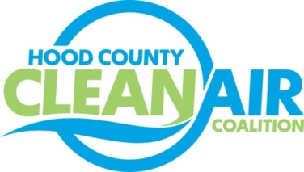
Meeting: Wednesday, June 27, 2018
Cresson City Council Chamber
8901 E. U.S. Highway 377 Cresson, Texas 76048
9:00-10:30 a.m.

Agenda

- Call Meeting to Order
- EPA Updates – Randy Pitre, EPA
- Local Updates – Michelle McKenzie
  - Review of May and June Meeting Summary
  - Annual Minutes
  - Review of Projects
    - Monthly Budget Review for March, April, and May
    - Status of Projects FY 16/17/18
    - Update Expense Approval Process
  - June Ozone Update
- Regional Updates – Michelle McKenzie
  - RTC Approved Mobility 2045 and 2018 Transportation Conformity – Presentation available at: https://www.nctcog.org/trans/committees/rtc/2018/06Jun/Ref.Itm_4.2.rtc061418.pdf
  - EPA Designations Published in Federal Register
  - EPA Issued Transportation Conformity Guidance for 2015 Ozone NAAQS Nonattainment Areas
  - Upcoming DFW Clean Cities Events: https://www.dfwcleancities.org/dfw-clean-cities-meetings
  - Funding Opportunities
    - TERP Light-Duty Rebate Incentive
    - Propane Council of Texas Funding for Propane Mowers and Trucks
- Other Discussion
- Adjourn

